Sunday, August 27, 2017 01:23:49 PM

Prime Minister Sheikh Hasina distributing seedlings among the flood-hit farmers at the Gobindaganj Upazila Parishad Compound on Saturday.
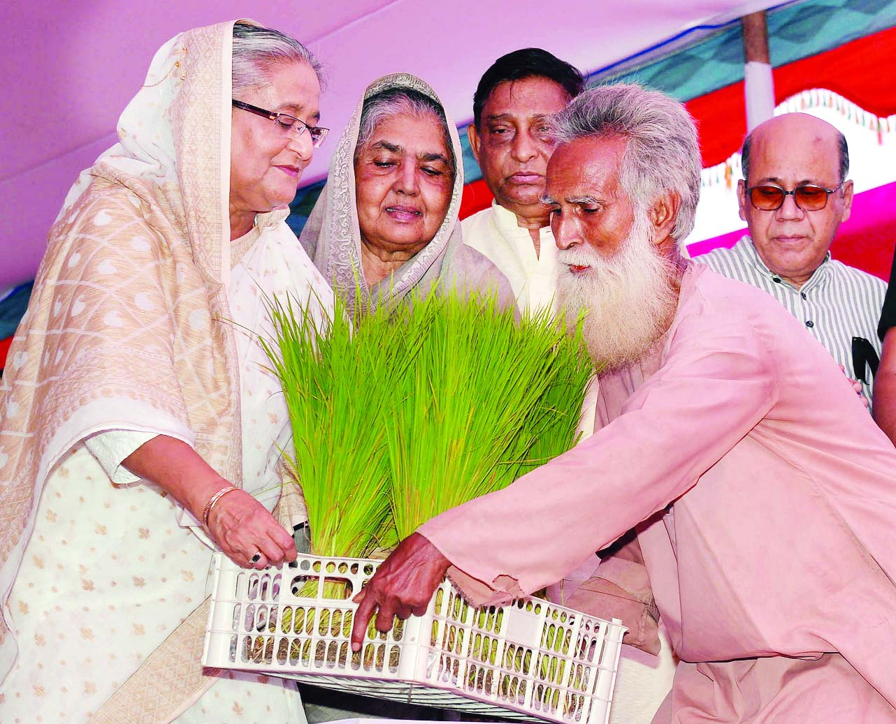
photo by
Prime Minister Sheikh Hasina distributing seedlings among the flood-hit farmers at the Gobindaganj Upazila Parishad Compound on Saturday.

